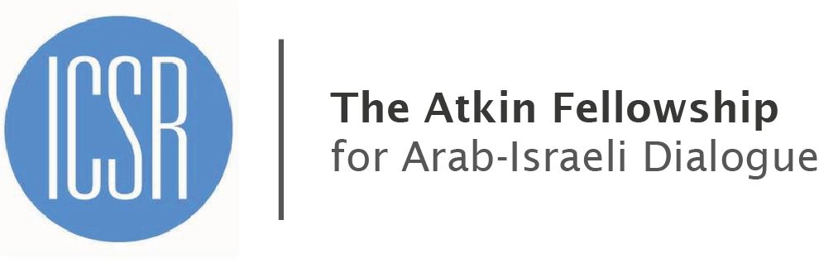

ATKIN FELLOWSHIP APPLICATION FORM
If you have any questions please email: katie.rothman@icsr.info
The application deadline is 13 June 2013.

FELLOWSHIP TIMING
The Atkin Fellowship runs from 1 October 2013 – 31 January 2014 and 1 February 2014 – 31 May 2014. Please highlight which timing is preferable:

1 October 2013 – 31 January 2014 1 February 2014 – 31 May 2014

PERSONAL DETAILS
Surname/Family Name:
Other Names (in Full):
Marital Status: |  | Sex (F/M):
Country of Birth: |  | Nationality:
Current Occupation:
Contact Address:

Tel. No.:
Email:

CV

FELLOWSHIP RESEARCH PAPER

A provisional outline of the paper which you intend to complete during your Fellowship (200 words)

APPLICATION QUESTIONS
Where did you hear about the Atkin Fellowship?

How will you benefit from the Atkin Fellowship? (200 words)

In your opinion, what measure will have the greatest positive impact on the Arab-Israeli conflict? (200 words)

How do you think ICSR might benefit from your time here? (For example, what new perspectives will you bring, do you have any ideas for activities you would like to arrange?)
(200 words)

APPLICATION SUBMISSION

Applicant signature: Date of submission:

PLEASE SEND THIS APPLICATION FORM BY EMAIL TO katie.rothman@icsr.info

The application deadline is 13 June 2013.

